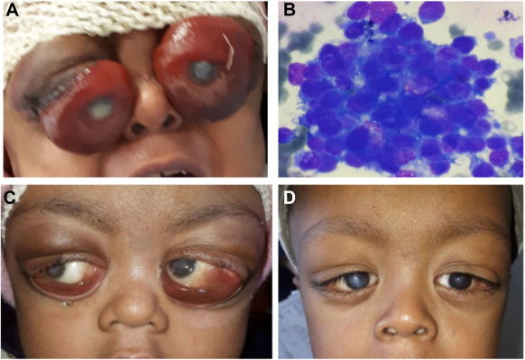

A, The child exhibitedsevere proptosis, severe chemosis, exposure keratopathy, corneal ulcers, limited extraocular movements, and decreased visual acuity in botheyes. B, Cerebrospinal fluid analysis showed a cluster of neuroblastoma cells. The child underwent transconjunctival orbital decompressionsurgery to alleviate proptosis and relieve pressure on the optic nerve. Additionally, intrathecal chemotherapy was administered to targetcentral nervous system involvement. C, The child’s response to treatment was remarkable, as the proptosis subsided, and extraocularmovements returned to normal. Although corneal scarring remains (D), there has been an improvement in visual acuity.Based on the provided images and clinical description please make an ophthalmic diagnosis for this patient. And output the diagnostic conclusions only.

**Orbital Metastasis from Neuroblastoma**